**Neha Malhotra**  **R.L. Institute M: 9416974837**

**Max Time : 1 hr** **Class = 12th Biology Test**  **Max Marks : 25**

**PRINCIPLES OF INHERITANCE & VARIATION**

**[Sex determination , Disorders and Pedigree analysis]**

1. Multiple choice questions : [ 1 X 4 = 4]
2. Inheritance of skin colour in humans is an example of :

|  |  |  |  |
| --- | --- | --- | --- |
| a) Point mutation | b) Polygenic character | c) Co-dominance | d) Chromosomal aberration |

1. Condition of a karyotype 2n + 1 , 2n –1 and 2n + 2 , 2n –2 are called

|  |  |  |  |
| --- | --- | --- | --- |
| a) Aneuploidy | b) Polyploidy | c) Allopolyploidy | d) Monosomy |

1. In a certain taxon some have 17 chromosomes and the others have 18 chromosomes. The 17 and 18 chromosome bearing organisms are :

|  |  |
| --- | --- |
| a) males and females respectively | b) Females and males respectively |
| c) all males | d) all females |

1. Mongolism or Down’s syndrome occurs when the patients have :

|  |  |
| --- | --- |
| a) 45 chromosome instead of 46 | b) 47 chromosome instead of 46 |
| c) 23rd chromosome in three doses | d) Non-disjunction of 21st chromosome |

1. Mention the combination of sex chromosomes in a male and afemale bird. [ 1 ]
2. Give an example of human disorder that is caused due to single gene mutation. [ 1 ]
3. Define deletion and Inversion type chromosomal mutation. [ 2 ]
4. What is Pedigree analysis? Suggest how such an analysis can be useful. [ 2 ]
5. Name and explain human gnetic disorder due to the following : [ 2 ]

(a) An additional X-chromosome in a male

(b) Deletion of one X-chromsome in a femlae

1. Haemophilia is sex linked recessive disorder of humans. The pedigree chart given below shows the inheritance of haemophilia in one family. Study the pattern of inheritance and answer the following questions : [ 2 ]

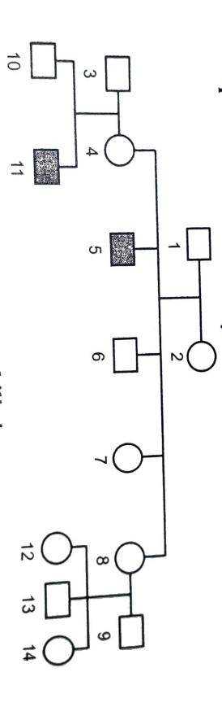

1. Give all the possible genotypes of the members 4, 5 and 6 in the pedigree chart.
2. A blood test shows that the individuals 14 is a carrier of haemophilia. The member numbered 15 has recently married with the member numbered 15. What is the probability that their first child will be a haemophilic male?
3. Marriage between a normal couple resulted in a son who was haemophilic and a normal daughter. In course of time, when the daughter was married to a normal man, to their surprise the granson was also haemophilic. [ 2 ]
4. Represent this cross in the form of pedigree chart. Give the genotypes of the daughter and her husband.
5. Write the conclusion you drawn from the inheritance pattern of this diseases.
6. Explain mechanism of sex determination in Birds and Insects (like Cockroach). [ 3 ]
7. Both Haemophilia and thalessemia are blood related disotrders in humans. Write their causes and the difference between the two. Name the category of genetic disorder they both come under. [ 3 ]
8. Mention any two Autosomal genetic disorders with their symptoms. [ 3 ]